CS-006 Resin Infusion
Doc ID | CS-006
Title | Resin Infusion
Revision | D
Status | Draft, pending Lead signature
Effective date | 2026-10-10
Supersedes | Resin Infusion Beginner Guide (SN5), retained as intro reading; its "30 psi vacuum" figure is wrong (see §7.4)

Approvals
Role | Name | Date
Author | Simon Starbuck (drafted with Claude, SN6 Resources) | 2026-07-12
Reviewer | simon (reviewer agent) | 2026-10-10
Approver (Composites Lead)

Revision history
Rev | Date | Author | Description of change
A | 2026-07-12 | Claude | Initial issue. Fixes G0 review findings on the old guide: impossible vacuum number, missing resin trap, no numeric leak-down criterion
B | 2026-07-28 | Claude | Language pass: fewer em dashes for rhythm variety, no content change.
C | 2026-08-28 | Claude | Engineering pass (CS-000 Rev C conventions). Figure 1 draws the whole loop, pot to pump, with the two rules people miss when learning from over-the-shoulder: the mesh break before the outlet and the trap between bag and pump. Purpose reworded from shop slang to a statement a tech inspector could read; the Slack quote stays. No rule changed.
D | 2026-10-10 | Claude (doc overhaul, requested by Simon Starbuck) | §7.6 demould now follows the FEB hold (48 h SLOW, 24 h FAST from inlet clamp, CS-008 §5.1), datasheet figure kept as such. §6 hazards corrected to the SDSs. SLOW pot life planned at 80-100 min (the TDS disagrees with itself). App training gate, drop-test note and Infuse cure record named. Airtac distance and wait added; a may for topping up on long infusions; two troubleshooting rows; new §7.8: degassing as an optional step (Simon, 2026-10-10); tacky tape named: Airtech AT-200Y. IN2 H360F added to §6. PPE the SDSs ask for: EN 166 glasses as a shall, the respirator with the stocked A + P100 cartridges as a shall in a closed room or long session and ABEK as a should, on the purchase list (Simon, 2026-10-10; R-008-30). §4 trap sentence unbolded (R-006-15). Fact-check: the 0.5 m rule is cited to the SN5 primer (new R8); FAST pot life planned at 9-14 min and the SLOW text figure carries no temperature; the 20-30 min infusion time is R7's larger-piece figure; the stocked cartridge is A + P100 (R-006-30); the unsourced IN2 vapor-pressure claim dropped; a should on medical advice for H360F (SDS P201, P308 + P313); team numbers labelled as team rules; tacky tape outboard of everything in the bag; no IPA on a released mold; soapy water kept off the bag; a shut-off valve with the gauge on the bag side, reopened after the drop test (new §7.4 step 4); the mold record updated at demould (new §7.6 step 4); a live dry patch goes to the experienced infuser; the app's words instead of "training gate". Register R-006-01..15, R-006-30.

1. Purpose
Infusion is our main process for big parts, and in SN5 it ran without acceptance criteria: no numeric leak-down limit ("air started leaking in toward the end, hopefully it will turn out okay", #composites, 2026-05-01), an inherited guide asking people to find a physically impossible "30 psi" of vacuum, and no resin trap mentioned anywhere between bag and pump. This doc gives the numbers.

2. Scope
Resin infusion of CF/glass laminates on sealed tooling-board molds (CS-004) or flat glass/table plates, using the team's IN2/AT30 system. Wet layup: CS-007.

3. References
Ref | Document | Where
R1 | IN2 Infusion Resin TDS | 03 Datasheets/EC-TDS-IN2-Infusion-Resin.pdf
R2 | IN2 resin, AT30 SLOW hardener and AT30 FAST hardener SDSs (one combined file; AT30 SLOW v7.0, 2024-07-10; AT30 FAST v6.0, 2022-09-08) | 03 Datasheets/EC-SDS-IN2-Epoxy-Infusion-Resin-and-Hardener.pdf
R3 | VB160 bagging film TDS/SDS | 03 Datasheets/EC-TDS-VB160-Vacuum-Bagging-Film.pdf, EC-SDS-VB160-Vacuum-Bagging-Film.pdf
R4 | PP180 peel ply TDS | 03 Datasheets/EC-TDS-PP180-Peel-Ply.pdf
R5 | Airtac 2 spray adhesive TDS (Airtac 2 Improved, updated 2020-03-03) / SDS (the 2005 MSDS of the earlier Airtac 2 Spray Adhesive; a current SDS is wanted) | 03 Datasheets/airtac2imp.pdf, airtac2spray.pdf
R6 | CS-002 (stack), CS-004 (mold prep), CS-008 (resin handling) | this series
R7 | Resin Infusion Beginner Guide (SN5, background reading only) | SN5 Composites/Documentation/Resin Infusion Beginner Guide.docx
R8 | Composites Info & Safety (SN5 primer) | SN5 Composites/Composites Info & Safety.docx

IN2/AT30 key numbers (from R1 unless the row says otherwise):
Property | Value
Mix ratio | 100 : 30 resin : hardener by weight (FAST or SLOW hardener, same ratio)
Pot life | SLOW: the TDS table says 120–150 min at 25 °C and its text says 80–100 min (no temperature given); plan on 80–100 min. FAST: the table says 10–14 min at 25 °C and the text 9–14 min; plan on 9–14 min
Gelation @25 °C | SLOW: 8–10 h · FAST: 2–4 h
Demould @25 °C (datasheet figure) | SLOW: 18–24 h · FAST: 6–8 h
FEB hold before demould (team hold, not R1) | SLOW: 48 h · FAST: 24 h, counted from inlet clamp time (CS-008 §5.1; app/resins.js)
Full mechanical properties | ≥14 days @25 °C (no oven post-cure available)
Hardener choice | SLOW for anything larger than a coupon; FAST only for small parts where you are confident of infusion time

4. Definitions
- inHg: inches of mercury, what the team's gauges read for vacuum. Full vacuum at sea level ≈ 29.9 inHg; nothing reads "30 psi of vacuum", since atmospheric pressure is only ~14.7 psi. The old guide's "30 psi" figure was a gauge-scale mix-up; if a gauge shows psi, it is reading something else.
- Drop test / leak-down: isolating the bag from the pump and watching the gauge to quantify leaks before committing resin.
- Resin trap / catch pot: sealed container between bag outlet and pump that catches over-pulled resin. Without it, the first overlong pull kills the vacuum pump.
- Pleats: folds built into the bag with tacky tape so film can reach into corners without bridging or tearing.
- Race-tracking: resin finding a fast path (usually along edges) and reaching the outlet before wetting the middle.

5. Equipment & Materials
Item | Spec / product | Source | Notes
Resin system | IN2 + AT30 SLOW (default) | Easy Composites | R1; order ≥6 weeks ahead (PP-02)
Bag film | VB160 | Easy Composites | R3
Peel ply | PP180 (or Sigmatex-supplied) | Easy Composites / Airtech | R4
Flow mesh | Green infusion mesh (or 2-in-1 mesh/peel ply) | Easy Composites / Airtech | Cover the whole part
Tacky tape | Airtech AT-200Y (yellow) sealant tape (03 Datasheets/AIRTECH-TDS-AT-200Y-Sealant-Tape.pdf; safety sheet 03 Datasheets/AIRTECH-SDS-Sealant-Tapes.pdf) | Airtech | Keep backing tab on until final placement. If a new tape will not hold 27 inHg, go back to the last one that did and note the brand on the WO
Spiral wrap ½" + PE tubing ½" | Feed/vacuum lines | Airtech | Watch sharp-cut ends near the bag
Resin trap | Team catch pot | RFS | Mandatory in line before the pump
Vacuum pump + gauge (inHg) | Team pump | RFS
Shut-off valve | Between trap and pump | RFS | The vacuum gauge sits on the trap or bag side of the valve, never on the pump, so a closed valve still shows the bag (§7.4 step 2)
Tack spray | Airtac 2 | Airtech | R5; light mist only, from at least 30 cm (§7.2 step 2)
Digital scale, cups ×2, sticks | 1 g resolution | Consumables | Double-pot mixing (CS-008)
Clamp/hose clamp for feed line | Any | RFS | The "clamp" in §7.5

6. Safety
Per R2 (§2 of each SDS): IN2 resin causes skin irritation, serious eye irritation and allergic skin reactions, and may damage fertility (H315, H319, H317, H360F). AT30 hardener, SLOW and FAST, is corrosive: it causes severe skin burns and serious eye damage (H314, H318), causes allergic skin reactions (H317) and is harmful if swallowed (H302). The AT30 FAST SDS adds possible organ damage through prolonged or repeated exposure (H373) and corrosive to the respiratory tract (EUH071).
- Gloves: nitrile at all times once resin is out; change after any contamination.
- Eyes: safety glasses with side shields (EN 166) whenever resin or hardener is open (R2 §8.2).
- Respirator: in a closed room or a long session, wear the team respirator with the stocked A + P100 cartridges (CS-011 §5; CS-008 §6). You should use ABEK cartridges (EN 14387) instead (R2, AT30 SLOW and FAST §8.2); they are on the purchase list.
- Ventilation: mix and infuse in the ventilated shop area (R2 §8.2 asks for effective ventilation in all processing areas); sensitization is cumulative.
- Fertility: IN2 may damage fertility (H360F). Anyone who is pregnant, trying to conceive or concerned should get medical advice before handling it (R2: P201, P308 + P313), and may ask a lead for other work on an infusion night without saying why.
- Airtac 2 (R5): extremely flammable aerosol: no sparks/heat, use in ventilated space, short bursts.
- Exotherm: a full mixed pot of IN2 left standing will overheat (CS-008 rules apply: batch sizing, transfer promptly, hot cup → outside on concrete).
- Sharp spiral-wrap ends: cut ends pierce gloves and bags alike; tape them.

7. Procedure

7.1 Prerequisites
- Stack frozen and printed on the WO (CS-002 §7.2); mold sealed + released per CS-004 with quality checks passed.
- Materials staged: resin on hand ≥ (dry fiber mass × 0.65) × 1.3 (same formula as the mix math in 7.5, rounded up since infusion consumes mesh/line resin too), all consumables cut before any resin is mixed.
- Two people minimum for any part bigger than a coupon; one experienced with infusion (unchanged team rule, R7). In the app, the steps "Dry stack and bag", "Drop test, 1 inHg or less over 10 min" and "Infuse" are signed only by someone with Resin infusion training. Anyone without that training cannot sign them; only a lead can sign without it, and the reason goes in the work order's event log.

7.2 Dry stack and consumables
- Wipe the workspace with IPA. Dust the released mold with a clean, dry microfiber only: no IPA, water or solvent on wax or PVA (Partall Film #10 is a water- and alcohol-based PVA, CS-004 R3). Cut cloth per the WO ply table; weigh and record total dry fiber mass on the WO.
- Lay plies per the WO, tacking with Airtac 2 only where a ply needs holding: hold the can at least 30 cm (12 in) from the surface, mist lightly, and wait 10 s before placing the ply (R5). Heavy spray inhibits infusion.
- Peel ply over the full laminate + flange edges; flow mesh over the entire part stopping 30–50 mm short of the outlet side (team rule; R8 describes the break near the outlet but gives no distance). The mesh break slows resin at the end and reduces race-tracking through the exit.
- Place spiral-wrap feed line along the inlet side on the flange (not on part surface unless the WO says so; print-through), and the outlet spiral toward the catch pot. Max resin travel distance inlet→outlet ≈ 0.5 m (R8, rule of thumb; it varies with resin and part shape); larger parts need multiple feeds planned on the WO.
[ PHOTO: dry stack with mesh break visible near outlet spiral ]

7.3 Bag
- Tacky tape around the full perimeter on the outer edge of the flange, outboard of everything going in the bag (spirals, peel ply, mesh), with at least ½ inch between them and the tape so nothing overlaps it (R7). Keep the backing on until final placement.
- Cut VB160 oversized; add a pleat at every corner and every 300–400 mm of perimeter on curved molds (team rule).
- Fit through-bag connectors: outlet line → resin trap → pump (never bag → pump directly); inlet line → clamped shut.
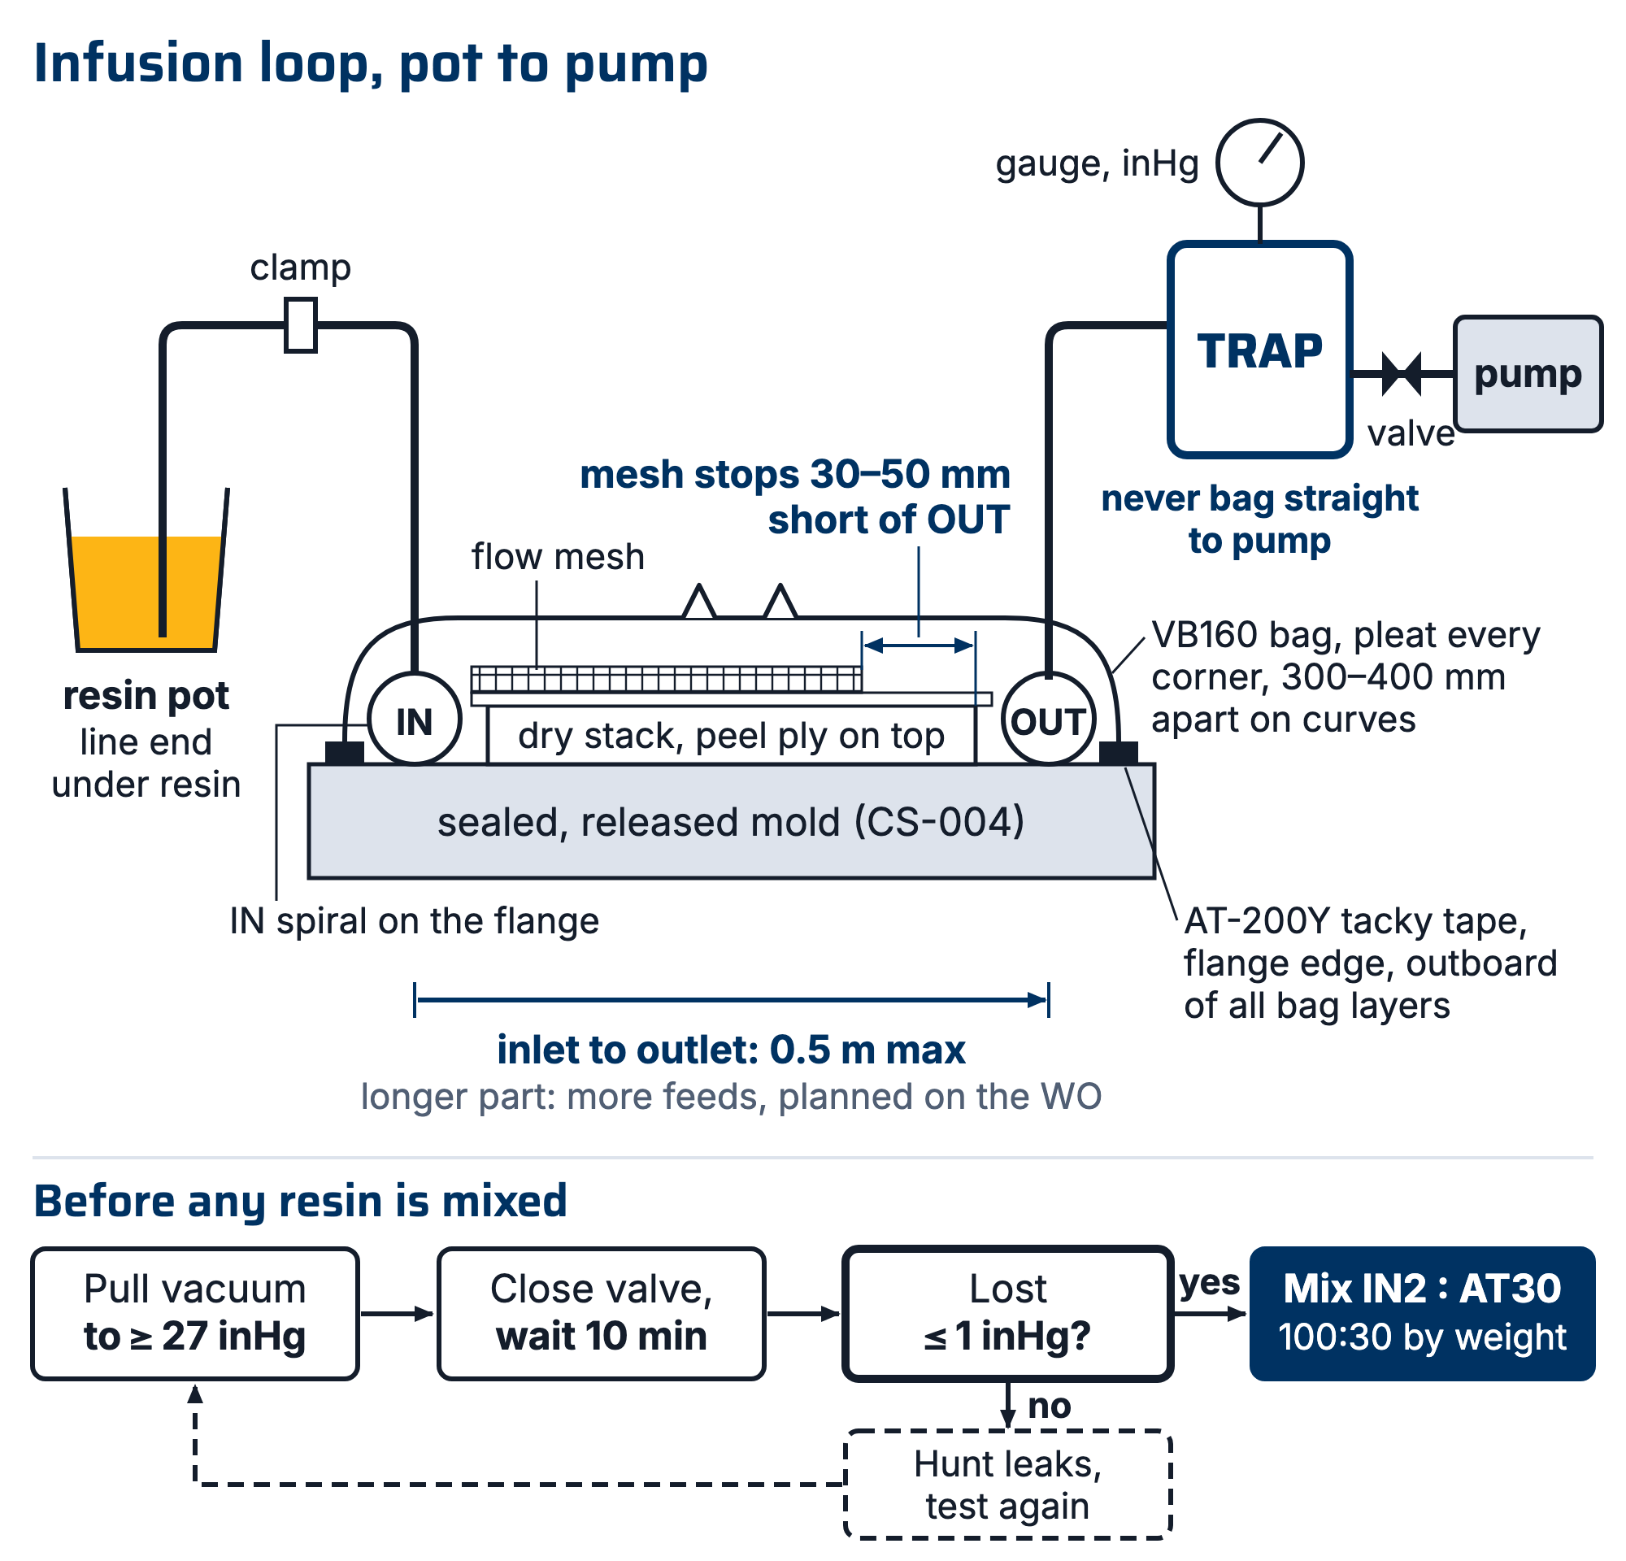
Figure 1. The full loop in section, pot to pump. The flow mesh stops 30–50 mm short of the outlet, the trap sits between bag and pump, and resin travel inlet to outlet stays at or under 0.5 m.

7.4 Pull vacuum and drop test: the blocker
- Pull vacuum. Target on the team gauge: ≥27 inHg (team acceptance criterion, set in Rev A; full vacuum is ~29.9 inHg at sea level; RFS altitude is negligible). If the gauge won't pass 25 inHg, hunt leaks now: press tacky tape seams, listen, re-seat pleats and connector bases.
- Drop test: close the valve to isolate the pump. The bag must lose ≤1 inHg over 10 minutes (team acceptance criterion, set in Rev A). The gauge must be on the bag side of the closed valve (§5). Write the start and end readings in the note on the work order's "Drop test, 1 inHg or less over 10 min" step; it will not take a member's signature without the note, and "Infuse" cannot be signed until it is. A lead can sign without it (Sign without it), and the reason goes in the work order's event log.
- Fail → keep hunting (seams, pleat folds, connector bases, spiral ends piercing the bag) and re-test. Do not mix resin until the drop test passes. This number is the difference between this standard and SN5's "hopefully it will turn out okay".
- Pass → open the valve again and check the gauge climbs back to 27 inHg before you open the inlet (§7.5 step 4). A closed valve left shut bleeds the bag down through the cure.
⚠ CAUTION: The drop test is cheap. A dry patch in a cured undertray panel is not. No pass, no resin, even at 11 pm with people waiting.

7.5 Mix and infuse
- Resin mass math: mix ≈ (dry fiber mass × 0.65) × 1.2–1.3 (team factors; tune them from WO records). The 0.65 factor covers the laminate (aiming ~60:40 fiber:resin by weight); the 1.2–1.3 multiplier covers mesh/line losses. Round up; starving the infusion mid-pull is unrecoverable, and leftover mixed resin is a known cost (record actual used vs mixed on the WO to tune this). On a long infusion you may mix the total as two or more smaller batches and top up the pot as it draws down, keeping the inlet submerged (R1).
- Mix IN2:AT30 100:30 by weight (R1) per CS-008 (double-pot, ≥2 min). SLOW hardener default: plan on 80–100 min pot life (the TDS text, no temperature given; its table says 120–150 min at 25 °C) (R1).
- Brace the resin cup; submerge the inlet line end fully (a slurping inlet injects the bubbles you just vacuumed out).
- With ≥27 inHg confirmed, open the inlet clamp slowly. Watch the flow front: even progress, no race-tracking. Typical infusion time: about 20–30 min on a larger piece, sometimes longer (R7); record yours on the WO.
- When resin reaches the outlet spiral and the laminate is fully dark/wet: clamp the inlet. Leave the pump running through gel (SN5 practice; the "no 24/7 vacuum" optimization was never validated, revisit only with a deliberate test).
- Record on the WO: times (mix, open, full-wet, clamp), resin mixed vs used, gauge readings, anomalies with photos. When you sign "Infuse", the app asks for the cure record: set Resin mixed to IN2 + AT30 SLOW (or IN2 + AT30 FAST), set Finished on and at to the time you clamped the inlet, and fill in "Shop temperature, °C (optional)". That time starts the hold on "Cure and demould".
[ PHOTO: flow front mid-infusion, even progress across the part ]

7.6 Cure and demould
- Do not demould before the FEB hold: 48 h for SLOW, 24 h for FAST, counted from the time you clamped the inlet (team hold, CS-008 §5.1). The work order's "Cure and demould" step stays locked until the hold passes; only a lead can override it, with a written reason. The datasheet demould figure is 18–24 h SLOW and 6–8 h FAST at 25 °C (R1). A colder shop runs longer than either; gel ≠ cured.
- Full mechanical properties take ≥14 days (R1); schedule trimming freely, but no structural/fit loading before then where avoidable.
- Demould, label part per CS-001, photograph, weigh, record in WO qualityChecks; hand to CS-009 for trim.
- On the Molds tab, open the mold, add 1 to Parts pulled and set Stage back to Sealed: the PVA came off with the part (CS-004 R3). It goes back to Ready for layup only after the next release (CS-004 §7.4 step 4, then §7.5 step 5).

7.7 Troubleshooting: leaks, dry spots, race-tracking
Symptom | Likely cause | Do
Gauge won't reach 25 inHg (bag leak) | Perimeter leak, connector base, pleat fold | Press seams, re-seat. Soapy water only on hose fittings and connectors outside the bag, never on bag film, pleats or tape seams over a dry stack; find those by pressing and listening
Passes to 27 then creeps down | Micro-leak: spiral end or bag puncture | Patch with tacky tape square; re-drop-test
Leak you cannot find | Air drawn in through the mold itself (unsealed back or sides, cracks), or a sharp mold edge or mesh corner piercing the bag | Sand or radius sharp mold edges, or edge them with breather; chamfer or tape down mesh corners; check whether the mold's back and sides were sealed; sealing them is shop practice (Larry, #composites 2026-04-03), and CS-004 does not yet require it
Resin racing along one edge | Race-tracking channel at the flange | Clamp inlet briefly; rely on mesh break; note for next mold (tape a dam)
Dry patch far from inlet | Mesh didn't cover; distance >0.5 m | If still wet: call the experienced infuser (§7.1 step 3) about an emergency second feed; do not pierce the bag yourself. [NICK TO CONFIRM: how the team adds a second feed through a bag under vacuum.] Cured: record as defect, assess vs qualityChecks
White/foamy resin at inlet | Bubbles from slurping cup | Re-submerge line; bubbles usually trap in mesh, note location
Bubbles under a sound bag | Air drawn in during the pull | If the bag still holds, flush more resin through before clamping the inlet (shop practice, Larry, #composites 2026-04-03)
Resin in the trap filling fast | Over-pull past full wet | Clamp inlet earlier next time; trap is doing its job; empty before it nears the pump port

7.8 Degassing the resin
Degassing is an optional step. The team degasses IN2 sometimes; the IN2 datasheet does not call for it (R1). Degas when the part shows its surface (a visible cosmetic face), when an earlier part from the same mold came out with pinholes or bubbles, or when the mix was stirred hard enough to look cloudy.
How: mix and double-pot first (CS-008 §7 step 3), then put the mixed cup in the degassing chamber and pull vacuum until the foam rises and collapses, then infuse straight away. [NICK TO CONFIRM: which chamber, what vacuum level and how long under the bell.]
What to watch:
- The foam rises several times the resin's height before it collapses. Leave headroom in the cup, or it boils over into the chamber.
- Time under the bell comes out of the pot life (80-100 min planned for SLOW, 9-14 min for FAST, R1). A FAST mix can spend most of its pot life under the bell, so check the clock before you start.
- A warm cup (exotherm starting) means the pot life is nearly spent. Do not infuse it; follow CS-008 for a hot cup.
Whether or not you degas, these steps keep air out of the laminate:
- Mix and double-pot per CS-008 §7 step 3 without whipping air into the cup.
- Keep the inlet line fully submerged in the cup for the whole infusion (§7.5 step 3).
- Hold at least 27 inHg before the inlet opens (§7.4 step 1, §7.5 step 4).
- Pass the drop test, 1 inHg or less over 10 min, before any resin is mixed (§7.4 step 2).
- If bubbles show at the flow front or in the cured part, note where on the work order (§7.5 step 6), and whether the resin was degassed.

8. Quality checks / acceptance criteria
Check | Target | Method | Record where
Vacuum before resin | ≥27 inHg | Gauge | WO
Drop test | ≤1 inHg / 10 min | Timed gauge readings | WO (start/end values)
Full wet-out | No dry patches visible through bag | Visual at clamp time + after demould | WO qualityChecks + photos
Resin usage | Mixed vs used recorded | Scale | WO
Part mass | Per WO target ±10% (team default) | Scale | WO qualityChecks

9. Records
WO records: drop-test numbers, times, batch masses, hardener speed, gauge log, the lots and materials recorded at the Infuse buy-off ("Which lots went in" and "Materials used"), photos (dry stack, bagged, flow front, demolded), deviations. These records are how the next season learns what 0.5 m really means on our parts.

